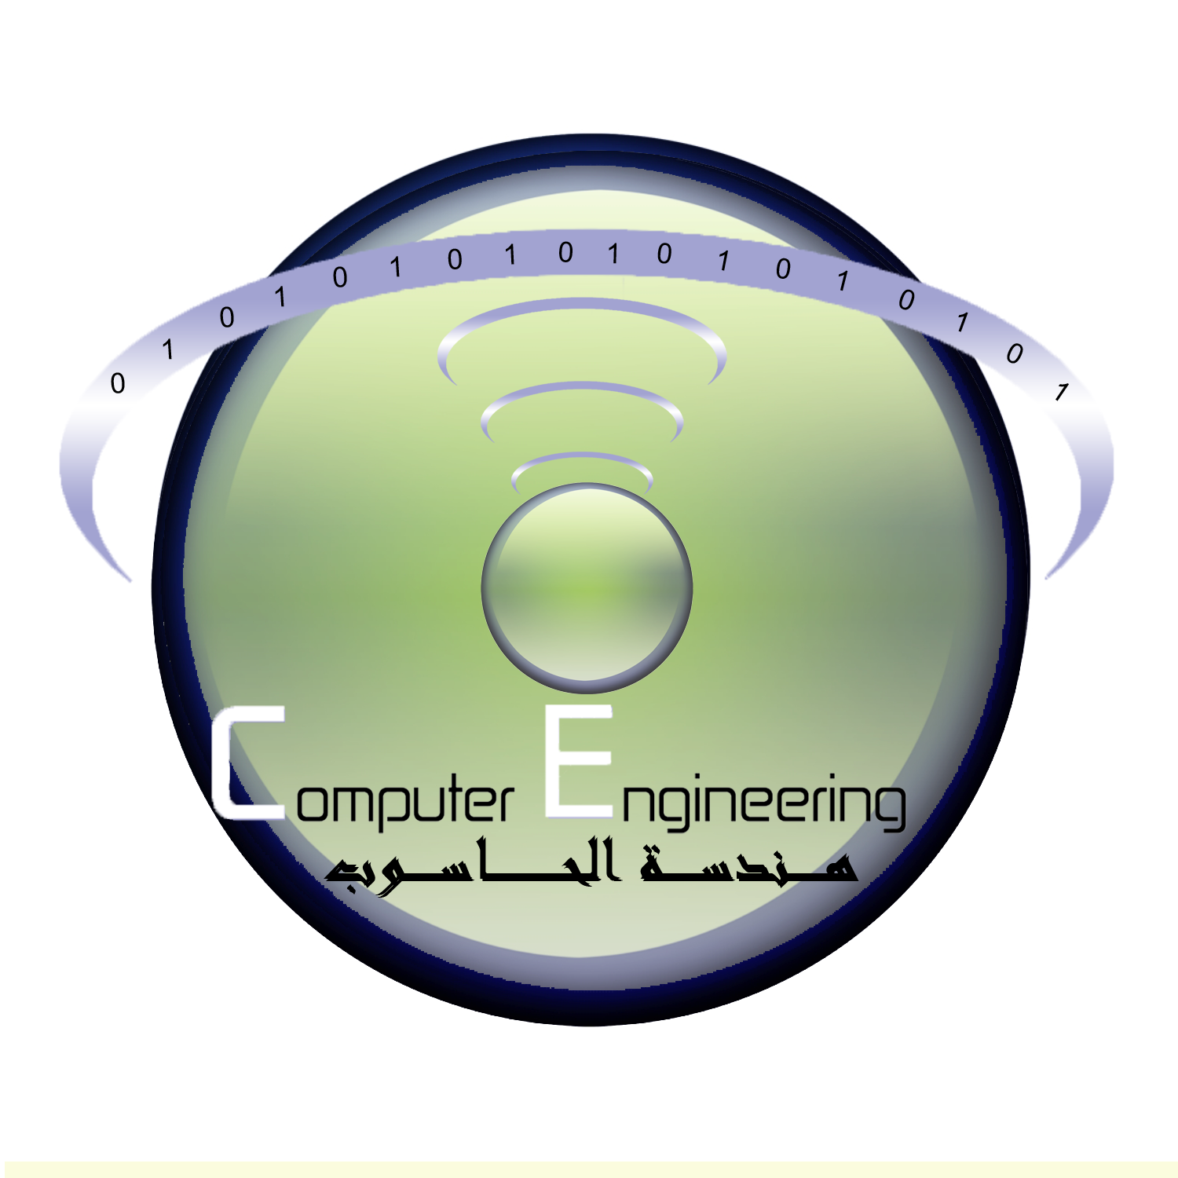
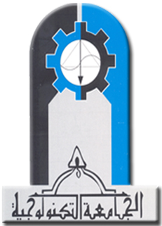

Ministry of Higher Education& scientific Research
University of Technology
Computer Engineering Department

Project Title (font 18Time new rom)

A project
Submitted to the Department of Computer Engineering
in the University of Technology in partial fulfillment of the Requirement for
the Degree of B.Sc of science In Computer Engineering

BY

Students Name(font 14Time new rom)

Supervised by

Name(font 14Time new rom)

(May2014)

